HW 06

**SECTION 01**

Launch

1.



2.

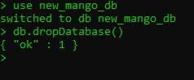

3.

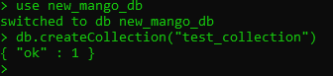

4.

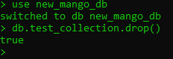

5.



6.



Without “.pretty()”



7.



8.







**Section 02**

1. db.restaurants.count()



2.db.restaurants.distinct(‘cuisine’).sort()

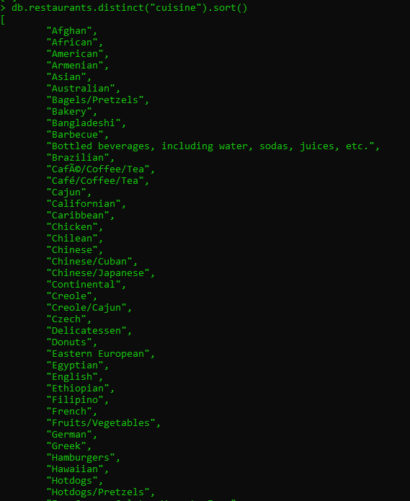

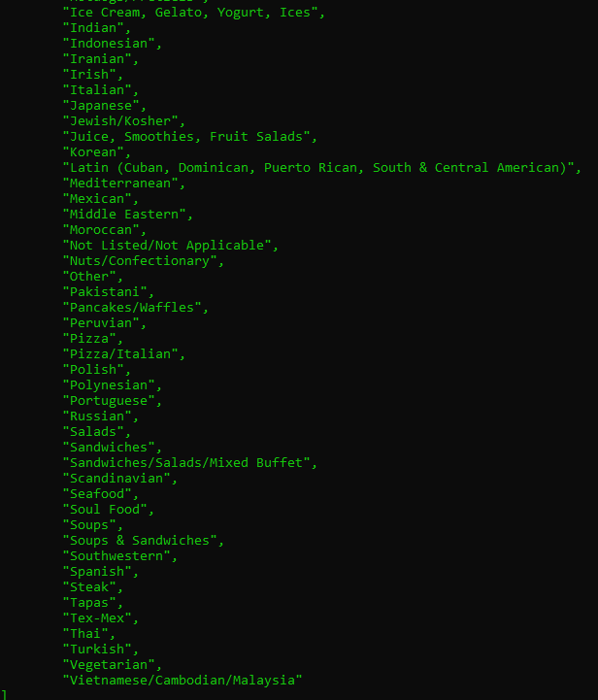

3. db.restaurants.find({‘address.zipcode’: “10025”, ‘cuisine’: “Chinese”}, {name: 1, _id: 0}).pretty()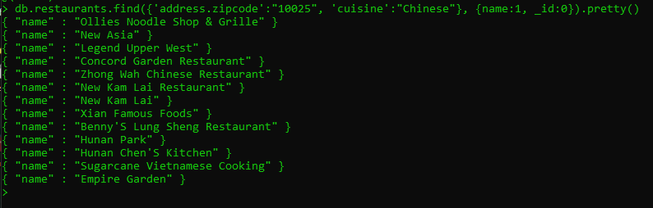

4.db.restaurants.find({$and:[{‘borough’: “Brooklyn”}, {$or:[{‘cuisine’: “Greek”, ‘cuisine’: “American”}]}]}).count()



5.db.restaurants.find({‘name’: /.*Cheese.*/i}, {‘name’: 1, ‘_id’: 0}).pretty()

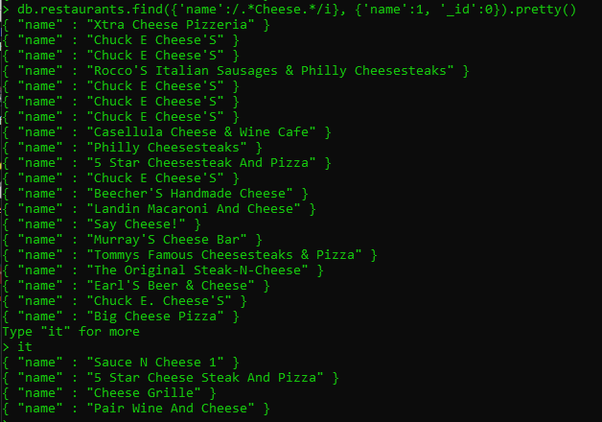

6. db.restaurants.aggregate([{$match:{'cuisine': "French"}}, {$group:{_id:"$borough", count:{$sum: 1}}},{$sort:{count: -1}}])

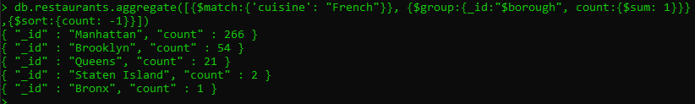

7. db.restaurants.aggregate([{$match:{'cuisine':"Italian", 'borough':"Manhattan"}}, {$unwind:"$grades"}, {$group: {_id: "$name", count:{$sum:"$grades.score"}}}, {$sort:{count: -1}},{$limit: 5}])

